**FEDERAL BOARD OF INTERMEDIATE AND SECONDARY EDUCATION**

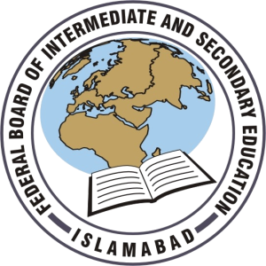

**DATE SHEET FOR SECONDARY SCHOOL CERTIFICATE**

**ANNUAL EXAMINATION 2021 SSC PART I & II**

|  |  |  |
| --- | --- | --- |
| **Date/Day** | **SSC PART I** | **SSC PART II** |
| 21-05-2021  Friday |  | English-II (Compulsory) (501) |
| 24-05-2021  Monday | English-I (Compulsory) (001) |  |
| 25-05-2021  Tuesday |  | Chemistry-II (512) |
| 27-05-2021  Thursday |  | Islamiyat-II (Compulsory) (608) |
| 28-05-2021  Friday | Pakistan Studies-I (106) |  |
| 31-05-2021  Monday |  | Biology-II (513)  Computer-II (541) |
| 02-06-2021  Wednesday |  | Pakistan Studies-II (606) |
| 03-06-2021  Thursday | Chemistry-I (012)  General Science-I (015) |  |
| 07-06-2021  Monday | Biology-I (013)  Computer-I (041) |  |
| 08-06-2021  Tuesday |  | Physics-II (511) |
| 11-06-2021  Friday | Urdu-I (Compulsory) (002) |  |
| 14-06-2021  Monday | Physics- I (011)  Economics-I (018) |  |
| 15-06-2021  Tuesday |  | Mathematics-II (510) |
| 18-06-2021  Friday | Islamiyat-I (Compulsory) (108) |  |
| 21-06-2021  Monday |  | Urdu-II (Compulsory) (502) |
| 22-06-2021  Tuesday | Mathematics-I (010)  General Mathematics-I (114) |  |