**DR. A. Q. KHAN COLLEGE OF SCIENCE AND TECHNOLOGY BAHRIA TOWN PHASE-8**

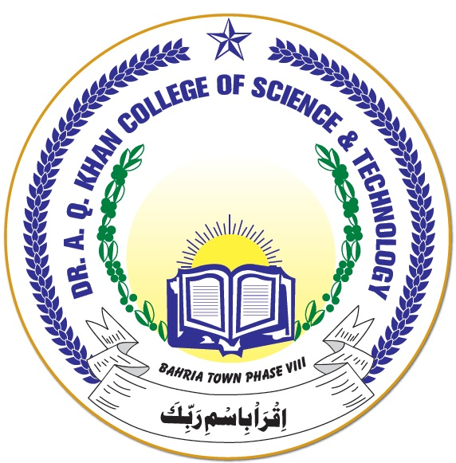

**DATE SHEET PRE-BOARD EXAMINATION CLASSES XI – XII**

|  |  |  |  |
| --- | --- | --- | --- |
| **DATE** | **DAY** | **XI** | **XII** |
| 26-04-2021 | Monday | Mathematics/Biology | ---- |
| 27-04-2021 | Tuesday | ---- | Physics/Statistics |
| 28-04-2021 | Wednesday | Chemistry/Computer Science | ---- |
| 29-04-2021 | Thursday | ---- | Mathematics/Biology |
| 03-05-2021 | Monday | Physics/Statistics | Chemistry/Computer Science |
| 04-05-2021 | Tuesday | English | Urdu |
| 05-05-2021 | Wednesday | Urdu | English |
| 06-05-2021 | Thursday | Islamiat | Pak. Studies |

**Note:**

1. Regular College timing will be observed during exams i.e 08:00 – 01:00.
2. Bringing cell phone/any recording device or any material which can be used as unfair means in exam is strictly prohibited.
3. In case of sudden announcement for a public holiday during exams, missing PAPER will be rescheduled right after the last paper.