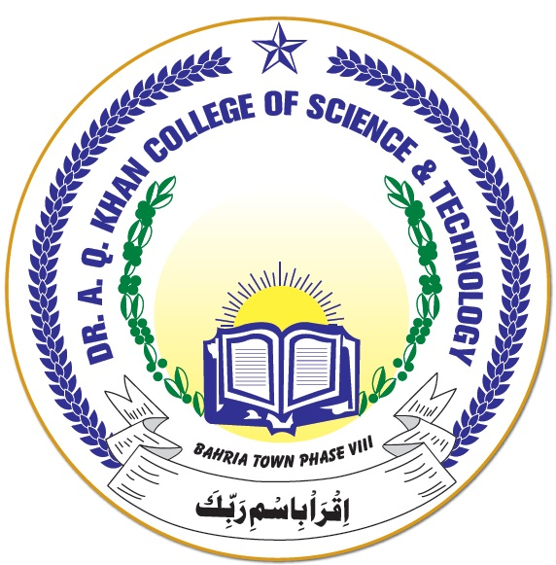

**DR A Q KHAN COLLEGE OF SCIENCE AND TECHNOLOGYBAHRIA TOWN PHASE – 8**

1. **Date Sheet for Online Examination for Class VI – VIII**

|  |  |  |  |  |
| --- | --- | --- | --- | --- |
| **S. No** | **Date** | **Day** | **Timing** | **Subject** |
| 1 | 30-03-2021 | Tuesday | 09:00 – 10:30 | Mathematics |
| 2 | 31-03-2021 | Wednesday | 09:00 – 10:30 | Urdu |
| 3 | 01-04-2021 | Thursday | 09:00 – 10:30 | English |
| 4 | 02-04-2021 | Friday | 09:00 – 10:30 | General Science |

1. **Date Sheet for Online Examination for Class I – V**

|  |  |  |  |  |
| --- | --- | --- | --- | --- |
| **S. No** | **Date** | **Day** | **Timing** | **Subject** |
| 1 | 30-03-2021 | Tuesday | 11:00 – 12:00 | Mathematics |
| 2 | 31-03-2021 | Wednesday | 11:00 – 12:00 | Urdu |
| 3 | 01-04-2021 | Thursday | 11:00 – 12:00 | English |
| 4 | 02-04-2021 | Friday | 11:00 – 12:00 | General Science |

1. **Instructions for Pre-School Classes**
2. Parents will collect question papers and answer sheet by visiting the College from 09:00 AM – 11:00 AM on 30th March, 2021.
3. All instructions regarding question paper will be written on it and parents will conduct the paper on their own at home, on the same day.
4. Parents will return answer sheets in sealed envelope to the College on 31st March, 2021 between 09:00 AM – 11:00 AM

**Note:**

All parents are requested to ensure that their children must attend online classes on

29th March, 2021, in which teachers will explain how to prepare and attempt online

papers.