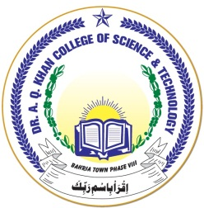

**DR. A. Q. KHAN COLLEGE OF SCIENCE AND TECHNOLOGY BAHRIA TOWN PHASE-8**

Dr. A. Q. Khan College of Science & Technology is the prime establishment in the chain of academic institutions founded by the Bahria Town. It started functioning with effect from September 01, 2009 but was formally inaugurated by the eminent nuclear scientist of Pakistan Dr. Abdul Qadeer Khan (whose name adorns the campus) on October 27, 2010. First Principal of college was Captain Muhammad Kazim (Retired) from Pakistan Navy who led the College from September 01, 2009 till October 18, 2020. The present Principal took over the responsibilities with effect from October 19, 2020. College campus is consisting of four main blocks, large play grounds, cafeteria and a stationery shop. Class rooms are very spacious, bright and well furnished. Well-equipped laboratories are available for the subjects of Computer, Physics, Chemistry and Biology respectively. A well stocked library, auditorium and multipurpose halls are also part of the College infrastructure. The all season air-conditioning system adds comfort and convenience to the college ambience. Faculty members at all levels are highly qualified, well experienced and devoted to teaching & learning activities. College provides transport facility to the students coming from all phases of Bahria Town as well as to connected areas. There is co-education in this college at all levels from pre-school to HSSC. Classes are not formed on the basis of gender. Notwithstanding this, we are very mindful of the norms of our society and set a code of conduct for the students accordingly. As Dr. A. Q. Khan College of Science & Technology Phase-8, campus completes a decade of imparting quality education, its alumni makes us proud by bringing good name to this institute by excelling in leading universities of this country.